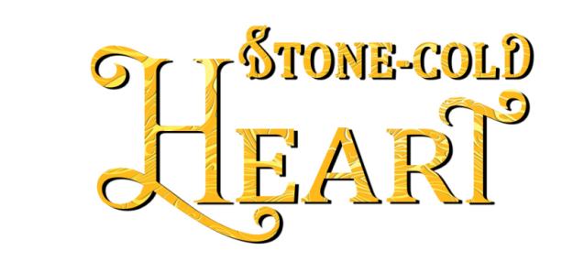

About Stone-Cold Heart, the fourth novel of the Mythos Legacy series:

Abandoned to his fate,
a shapeshifting gargoyle is trapped
until she sets him free…

A gargoyle betrayed by his soldiers…
After centuries of stone-cold death, Garrett discovers his legion has deserted him. Without their help, he’ll succumb to eternal sleep once more unless he can trick the woman who woke him into trusting him with her soul.
A combat veteran scarred inside and out…
Her last night in Afghanistan, Raquel Guerrero’s team fell victim to a suicide bomber, killing everyone but her. Now, despite her determination to never again let anyone close, her sense of duty compels her to help an endangered warrior survive.
Trust isn’t in their vocabularies…
A tentative truce frees them to investigate his regiment’s abandonment—and unleashes passionate temptations. But when the truth is uncovered, Garrett and Raquel’s fragile bond—and the healing power of love—might be the only thing that keeps them alive.

Amazon | iTunes | GooglePlay | B&N | Kobo | IndieBound | Additional Retailers

