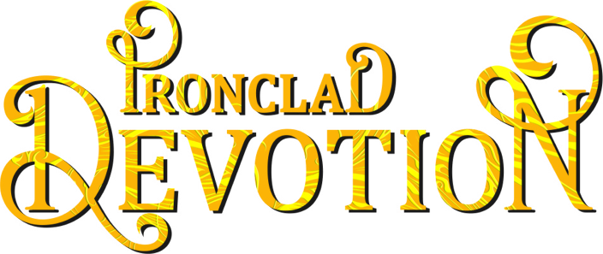

About Ironclad Devotion, the third novel of the Mythos Legacy series and winner of the 2015 National Reader’s Choice Award:

Safeguarding her freedom,
a faerie princess locks down her heart,
but a blacksmith forges the key…

A faerie princess evading her fate…
Earth is no place for a faerie, but Kira can’t go home without dooming her people. Desperate to avoid the pull of her homeland, she fosters an abandoned girl, the child’s joy a source of much-needed energy.
A blacksmith with something to prove…
When Zachary Chase discovers he has a daughter, he’s determined to be part of his child’s life and not repeat his mother’s neglect. But to open the little girl’s heart, he must earn her foster mother’s trust.
One night is never enough…
Despite their rivalry, Kira and Zac’s desires tempt them into one no-consequences night. Yet the more passion flares between them, the more Kira risks destroying the life she’s carved out on Earth—and endangering those she cares about in both worlds.

Amazon | iTunes | GooglePlay | B&N | Kobo | IndieBound | Additional Retailers

